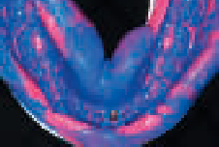

J. Perrin
H. Plard
J. Lambert
P. Limbour
Compressive implant-supported prosthesis: for the Axiom® 2.8 mm system
The Axiom® 2.8 is a small-diameter implant used in the treatment of narrow gaps, such as agenesis or root proximities. The characteristic of this system is its prosthetic assembly, not screw-retained or cement-retained but compressed directly on the implant.
KEYWORDS: 1 impacted prosthesis1 mini-implant 1 Axiom® 2,8

SUMMARY

Impacted prosthesis on implant: About the Axiom 2.8 mm system

The Axiom® 2.8 implant is a small-diameter implant that treats the narrow gaps as agenesis or root proximities. The particularity of this system is the prosthetic assembly that is not screw retained or cemented but impacted directly into the implant.

KEYWORDS: 1 impacted prosthesis 1 small diameter implant 1 Axiom® 2.8

he replacement of a missing tooth with an implant-supported prosthesishas been the selected treatment of choice
CLINICAL JOURNAL
Practical Guide
© Initiatives Santé 2016
T
for a number of years. This solution offers many advantages: comfort, aesthetic results, permanent treatment and preservation of adjacent teeth against edentulism.
However, implants are sometimes contraindicated due to lack of space or insufficient bone volume. Implant systems with reduced
implant diameters have been developed for minimal intervention in these narrow spaces.
This article describes the indications, limitations, survival rates and treatment protocol of mini-implants.
The Axiom® (Anthogyr) system is described and its use illustrated with a clinical case concerning the replacement of a missing mandibular incisor with a crown compressed on an Axiom® 2.8 implant.

MINI IMPLANTS

INDICATIONS AND LIMITATIONS
According to Davarpanah et al [1, 2], implant diameters are generally classified as follows:
- standard diameter 3.75 to 4.4 mm;
- small diameter 3 to 3.3 mm;
- large diameter 4.8 to 7 mm.
Mini implants have a diameter under 3 mm.
Only indications [1, 2] for single-component implant prostheses will be discussed here; other applications, such as axial attachment supports in removable prostheses, will not be discussed.
The application field for mini implants is relatively small. This type of implant is indicated in the following cases:
- narrow mesiodistal spaces (replacement of mandibular incisors and upper lateral teeth);
- in cases of narrow crests often related to agenesis of the same incisors, thus avoiding
thickening surgeries such as bone grafting for example (FIG. 1 and 2);
- when either the interradicular bone space or the cervical prosthetic diameter is limited.
The earliest mini implant systems marketed are monolithic, i.e. both the implant and the abutment form a single piece. The implant must be placed as close as possible to the axis of the future crown. The abutment, i.e. the supragingival portion, can be adjusted if needed. However, in the case of reduced space, adjustments may be limited and difficult to make. The indications of these monolithic implants are therefore limited.
Dual component mini implants, with independent implants and abutments, have been developed to overcome the limitations of single-component implants. It is thus possible, as for implant systems with a wider diameter, to choose abutments adapted to each situation (angulation, diameter and height). Finally, the emergence profile can be easily managed thanks to the wider choice of prosthetic components.

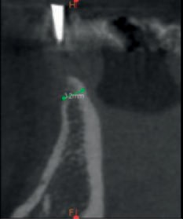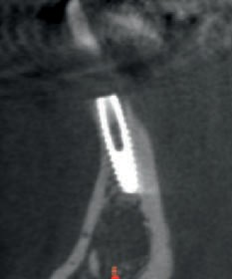

F_{IG}. 1 / X-ray cross-section (cone beam) showing a narrow bone crest.
© Initiatives Santé 2016
F_{IG}. 2 / X-ray cross-section (cone beam) after the placement of an Axiom® 2.8 implant.

© Initiatives Santé 2016

BIBLIOGRAPHY AND SURVIVAL RATE
In a 12-year retrospective study on 3,321 mini implants (diameter between 1.8 and 94,7 mm), Shatkin and Pettroto obtained a 3% survival rate in single-component fixed prostheses [3].
A recent meta-analysis of 22 studies shows the same survival rates in mini implants and standard implants [4]. The studies concern the use of mini implants not only in fixed prostheses but also as supports of removable complete and partial prostheses.
Recent studies show that the survival rates reported for mini implants fall between 94 and 100%. Only an older (1989) study shows a lower survival rate, under 90%. For some authors, the progress achieved both in terms of treatment of the implant surface and surgical or prosthetic techniques concerning this type of implant would explain the improved implant survival rates. According to recent medical literature, the use of mini implants in the indications mentioned above would represent a permanent solution in a single-component fixed prostheses.

COMPRESSIVE IMPLANT-SUPPORTED PROSTHESES AND THE AXIOM® 2.8 MM SYSTEM
A cylindrical-conical shape, this implant features a narrow implant apex suited to clinical situations of root proximity. The system is available in three lengths: 10, 12 and 14 mm.
The surgical protocol is traditional and very straightforward, limited to the use of various size burs. It will be described in detail in a clinical case presented later in this article.
Axiom® 2.8 is a dual component implant. Its characteristic lies in the fact that its prosthetic components are placed by compression. In fact, unlike the traditional use in implant prosthesis, the abutment-implant assembly is not screw-retained. This system requires no screwdriver or torque wrench [5, 6].
The implant-crown assembly is made with a pneumatic compactor: the Safe Lock® (FIG. 3 et 4). This instrument connects to a standard micromotor that generates pulses to compress the abutment or prosthesis into place. Its use is limited to compressing permanent abutments and crowns, as impression copings and temporary prostheses are placed manually.
This implant has a Morse tapered connection with integrated platform switching. However, it has no indexing system.
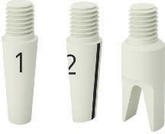
The abutment or single-component prosthesis is pressed on the implant, generating a significant resistance between the assembled walls, which retains the prosthetic device. This is called an active connection, as opposed to passive assemblies, where the retaining screw represents the main retention of the abutment
3
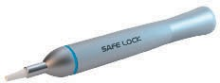
F_{IG}. 3 / The Safe Lock ® pneumatic impactor(© photo courtesy of Anthogyr, all rights reserved).

F_{IG}. 4 / The various tips that can be used with Safe Lock®: No. 1 is used to compress straight permanent abutments, No. 2 for permanent angulated abutments and No. 3 for cement-retained crowns extraorally (© photo courtesy of Anthogyr, all rights reserved).

or the screw-retained prosthesis.
The healing cap or coping is placed with a specific instrument, a gripper, which is screwed within the temporisation cap (FIG. 5).
To deploy the abutment or the implant prosthesis (temporary or final), the absence of a screw requires the use of pliers or forceps with slight lateral movements.
Prosthetic abutments are available in three gingival heights (2.5, 4.0 and 5.5 mm). To complement the straight abutments, three angulated elements are available (7, 15 and 23o).
The implant-prosthetic assembly can be done in two ways:
either the prosthesis is luted or cemented on the abutment extraorally, in the lab, and the piece is later deployed by pressure in the mouth, in the implant, using the compression instrument (FIG. 6);
or the abutment is compressed in the implant, then the crown is cemented or luted directly in the mouth (FIG. 7).
The Morse tapered connection has many advantages for the implant-prosthetic
restoration, both mechanically and biologically [7].
The mechanical resistance of the implant-abutment connection is higher than in the passive connection made on the implant platform (so-called plate configuration).
Due to the characteristic interlocking of this type of connection with an actual Morse tapered connection (3° conicity) as opposed to a plain conical connection, abutment micromovements in the implant are very limited under normal use.
The occlusal forces are better distributed on the implant, and, as a result, on the peri-implant bone.
From a biological perspective, the narrower gap between abutment and implant improves the adherence of the assembly, thereby preserving the soft tissues around the implant.
Finally, the effectiveness of the Morse tapered connection allows to use small-diameter implants without compromising the permanence of implant-prosthetic reconstruction [8], thereby reaffirming the concept of “more bone, less titanium” and avoiding bone injection in clinical situations of resorbed or narrow alveolar crests [9].

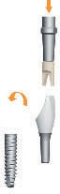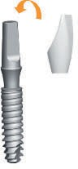

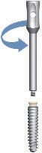
F_{IG}. 5 / The healing cap is deployed with the gripper (© photo courtesy of Anthogyr, all rights reserved).
© Initiatives Santé 2016
F_{IG}. 6 / The intraoral placement by pressure of the abutment-prosthesis unit assembled at the lab (© photo courtesy of Anthogyr, all rights reserved).
F_{IG}. 7 / Cementing the prosthesis intraorally on the previously compressed abutment (© photo courtesy of Anthogyr, all rights reserved).

CLINICAL CASE
A patient comes to consultation for the replacement of 41, extracted after endodontic failure (FIG. 8).
The image shows a very narrow bone crest as a result of post extraction resorption, which contraindicates the placement of an implant, even a small-diameter one.
The treatment plan includes a pre-implant restoration, 4 months after implant placement. It is agreed that a temporary crown will be put in place 3 months after implant surgery.
The reconstruction of the bone crest is traditionally performed with mandibular ramus bone grafts placed on the site and kept in place with two
osteosynthesis screws. The graft is protected with a Bio-Gide® (Geistlich) membrane (FIGS. 9-12).
Post-operative follow-up is moderate, clinically speaking, the situation appears favourable for the insertion of a mini implant (FIG. 13).
At the end of 4 months, the site is accessed again to place a 12 mm Axiom® 2.8 implant. The surgical placement sequences are straightforward, fast and accurate. Two burs are used, sizes 2 and 2.6 mm. Drilling to a depth of 1 mm longer than the implant is recommended. After the passage of each bur, an adapted gauge is used to check the implant axis (FIG. 14). In high density bone areas, the implant stress is limited by means of a tap. The position of the neck is slightly infracrestal in the proximal area

© Initiatives Santé 2016

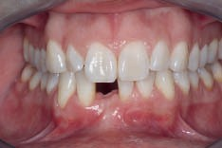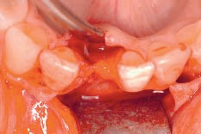
FIG. 8 / Clinical view of the initial situation. F_{IG}. 9 / Very narrow crest, unsuitable for a
small-diameter implant.
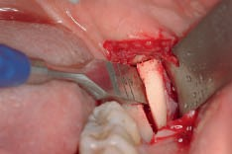
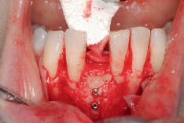
F_{IG}. 10 / Collection of autologous bone (ramus). FIG. 11 / Fixation of the graft by two osteosynthesis screws and
protection of the assembly by a resorbable membrane (Bio-Gide®, Geistlich).
3

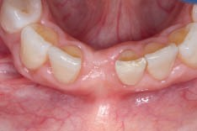
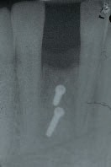
F_{IG}. 13 / Clinical situation after bone grafting, favourable to receive an implant.

F_{IG}. 12 / Follow-up X-ray after bone reconstruction.

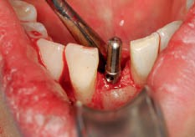
F_{IG}. 14 / Gauge used to check proper implant axis.
and crestal in the vestibular area (FIG. 15). The final tightening torque is 40 Ncm. A PEEK resin healing cap is pressed manually in the implant channel (FIG. 16).
Osteointegration is checked 3 months after surgery. Validation by clinical tests and imaging (FIG. 17-19) [10] allows continuation to the prosthetic stage.
An implant impression is made in order to place a temporary prosthesis (FIG.19). The impression coping for a so-called repositioned or “closed tray” impression is manually inserted in the implant (FIG. 20 and 21). Due to

© Initiatives Santé 2016

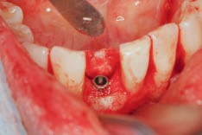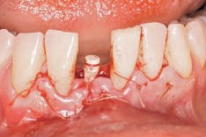
FIG. 15 / Implant placement. F_{IG}. 16 / Application of sutures and insertion of healing cap.

© Initiatives Santé 2016

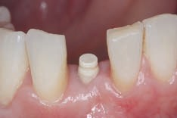

n18

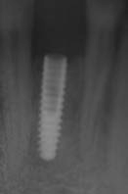
F_{IG}. 17-19 / Follow-up X-ray and clinical situation 3 months after implant placement. Notice the quality of peri-implant tissues.
n

17

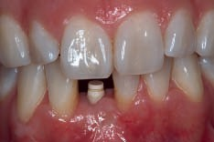
the Morse tapered connection, the Axiom® 2.8 system requires no screw-retained copings for the supported or “open tray” impression technique.

n19
After the impression is made (FIG. 22) at the lab, a temporary acrylic resin prosthesis is made on a temporary abutment (FIG. 23).
Its concave transgingival profile facilitates shaping of the peri-implant soft tissues [11, 12]. The temporary prosthesis is assembled on the temporary abutment extraorally, and the assembled unit is then placed on the implant without the use of cement adhesive (FIGS. 24 and 25).

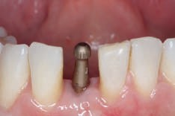

n20

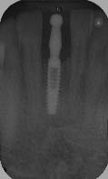
F_{IG}. 20 and 21 / Clinical and radiological view of the impression coping in place.

n21
3

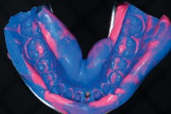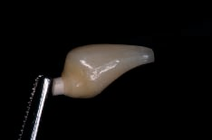

F_{IG}. 22 / Implant impression made with a double mixture (Hydrorise®, Zhermack).
F_{IG}. 23 / Temporary prosthesis assembled in the lab.

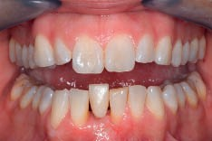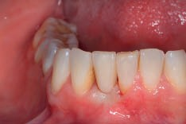

n24

n25
F_{IG}. 24 and 25 / Placement of the new temporary prosthesis.

After the soft tissues have stabilised over a 6-month period (FIG. 26), the impression used to construct the final prosthesis starts by adjusting the emergence profile obtained with the temporary prosthesis (_{FIG}. 27-30) [13, 14].
After making this impression, the final abutment is selected according to the specific clinical conditions of the case. The framework of the crown is made with pressed and layered lithium disilicate (IPS e.max®, Ivoclar Vivadent)

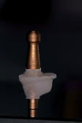

© Initiatives Santé 2016

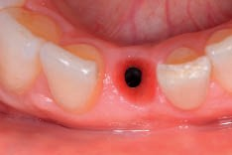
F_{IG}. 26 / Peri-implant soft tissue stabilisation.
F_{IG}. 27 / Customised coping for impression, after adjusting the emergence profile

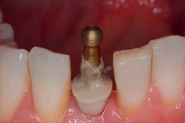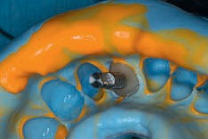

n28

n29

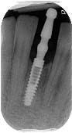
F_{IG}. 28-30 / Double mixture (Aquasil®, Dentsply) impression with customised coping.
n

30
n

30

For the assembly of the final prosthesis, luting is performed at the lab to avoid the difficulty of working intraorally.
© Initiatives Santé 2016
After a trial fitting and clinical check of the contact points, shape and colour of the crown alone without the abutment, the prosthesis is then luted on the infrastructure (Multilink Hybrid Abutment® adhesive, Ivoclar Vivadent).
The complete prosthesis is finally compressed on the implant, without the use of cement adhesive. The extraoral assembly of the abutment and temporary and final prostheses eliminates the need for cement adhesive on the clinical site, thereby avoiding difficult manoeuvres of removing excess adhesive in narrow, hard-to-reach spaces. The solution adopted is similar to the no cement [15] solutions that rely on the use of abutments and telescopic prostheses that do not require the use of cement adhesive.
The only limitation of this assembly protocol is the adjustment of the contact points and the precise length of the free prosthetic edge in the lab, which is not always easy to do, as it requires subsequent compression on the working model. Similarly, the final trial fit of the crown is a delicate operation, as compression placement and removal with pliers entail the risk of damaging the cosmetic material. This is probably the main pitfall of compressive single-component implant-prosthetic restorations. To avoid this, some practitioners use cement adhesive on the compressed abutment directly in the oral cavity [16].
As for all implant-supported prostheses, particular care should be taken to check occlusion
(FIG. 31).
Finally, the patient is instructed on good hygiene practice around the implant(FIGS. 32 and 33).

3

© Initiatives Santé 2016
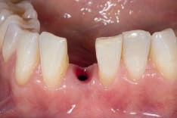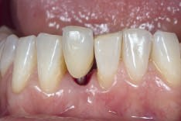

n31

n32
F_{IG}. 31 and 32 / Compression of final prosthesis.

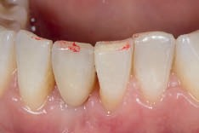
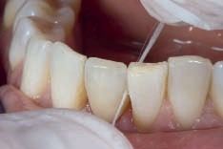
F_{IG}. 33 / Checking occlusion and length of free edge. F_{IG}. 34 / Checking contact points.

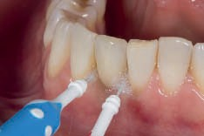
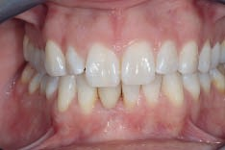
F_{IG}. 35 / Instructions on proper interproximal hygiene. F_{IG}. 36 / Final result, arches in occlusion.

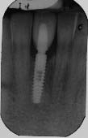 | FIG. 37 / Follow-up X-ray at the end of treatment. | CONCLUSION  The use of an implant system associated with an active connection with a Morse tapered cone allowing compression eliminates the need for assembly screws. This allows for the safe use of these mini-implants, with a reduced implant diameter, in situations of implant-supported prosthetic reconstruction to be performed in sites where the mesio-distal space and residual bone volume are very limited.  The authors wish to thank Anaïs Marguerite of Anthogyr for her helpful contribution and advice.  14. Hinds KF. Registration of the healed tissue in the esthetic implant  restoration. Int J Periodontics Restorative Dent 1997;17:585-591.  15. Rousselet B.Le remplacement des dents de petit diamètre dans les  zones esthétiques : une nouvelle alternative, l’implant Axiom de diamètre  2,8 mm. Implant 2011;17:109-117.  16. Layet M. Mise en place des principes du scellement sans ciment :  concept NoCem. Illustration par une mise en function immediate d’une  prothèse totale sur 4 implants Kontact équipés de piliers Isopost.  Implant 2011;17:119-128.  Jérémie Perrin  Doctor of Dental Surgery  Former University Hospital Assistant Associate Practitioner (Prosthesis subdivision)  Hervé Plard  Doctor of Dental Surgery  University Hospital Assistant (Prostheses subdivision)  Julien Lambert  Dental Prosthetist  Patrick Limbour  Doctor of dental surgery MCU-PH  Director of Oral Surgery and Implantology subdivision  Odontology and Oral Surgery Centre Rennes University Hospital  2, place Pasteur  35033 Rennes cedex 9  Bibliographic references  This article may be searched or cited under the following reference: Perrin J, Plard H, Lambert J, Limbour P. Compressive implant-supported prosthesis: The Axiom® 2.8 mm system. Implant 2016;22:307-317.  CONFLICT OF INTERESTS: the authors declare no conflict of interest regarding this article.  Acknowledgements: The authors wish to thank Anaïs Marguerite of Anthogyr for her helpful contribution and advice.
BIBLIOGRAPHY

1. Davarpanah M, Martinez H, Kebir M, Tecucianu JF. Manuel d’implantologie
clinique. Concepts, protocoles et innovations récentes. Rueil-
Malmaison : CdP, 2012.
2. Davarpanah M, Martinez H, Tecucianu JF, Celletti R, Lazzara R.
Small-diameter implants:indications and contraindications. J Esthet
Dent 2000;12:186-194.
3. Shatkin TE, Pettroto CA. Mini dental implants: a retrospective analysis
of 5 640 implants placed over a 12-year period. Compend Contin
Educ Dent 2012;33:2-7.
4. Sohrabi K, Mushantat A, Esfandiari S, Feine J. How successful are
small-diameter implants? A literature review. Clin Oral Implants Res
2012;23:515-525.
5. Fromentin O, Popelut R. Comprendre et contrôler le vissage en
prothèse supra-implantaire. Première partie : aspects théoriques des
phénomènes de vissage et de dévissage. Alternatives 2005;29:43-51.
6. Fromentin O, Popelut R. Comprendre et contrôler le vissage en
prothèse supra-implantaire. Deuxième partie : pérennité du vissage
et conception implanto-prothétique. Alternatives 2005;28:65-74.
7.SchneckE,ChapotatB.Influence de la connectique cone morse dans
le maintien des tissus péri-implantaires. Implant 2011;17:203-214.
8. Hermann JS, Schoolfied JD, Schenk RK, Buser D, Cochran DL.
Influence of the size of the microgap on crestal bone changes
around titanium implants. A histometric evaluation of unloaded
non-submerged implants in the canine mandible. J Periodontol
2001;72:1372-1383.
9. Merz BR, Hunenbart S, Belser UC. Mechanics of the implant-abutment
connection: an 8-degree taper compared to a butt joint connection.
Int J Oral Maxillofac Implants 2000;15:519-526.
10. Albrektsson T, Zarb G, Worthington P, Eriksson AR. Thelong-term
efficacy of currently used dental implants: a review and proposed
criteria of success. Int J Oral Maxillofac Implants 1986;1:11-25.
11. Rompen E, Raepsaet N, Domken O, Touati B, Van Dooren E. Soft
tissue stability at the facial aspect of gingivally convergingabutments
in the esthetic zone: a pilot clinical study. J Prosthet Dent 2007;97
(suppl.):S119-S125.
12. Perrin J, Plard H,Lambert J, Lecerf J. Gestion des tissus mous périimplantaires
du secteur antérieur par la prothèse temporaire. Implant
2016;23:125-133.
13. Davarpanah K, Demurashvili G, Szmukler-Moncler S. Empreinte
des tissus mous en prothèse implanto-portée. Cah Prothèse
2013;162:37-42.

© Initiatives Santé 2016

